

**DISBURSED LINKED INDICATOR (DLI) 4**

**IMPROVED INVESTMENT PROMOTION ENVIRONMENT**

**DELTA STATE GOVERNMENT INVESTMENT INCENTIVES INVENTORY**

**DELTA STATE INVESTMENTS DEVELOPMENT AGENCY (DIDA)**

|  |  |  |  |  |  |  |  |  |  |  |
| --- | --- | --- | --- | --- | --- | --- | --- | --- | --- | --- |
| S/NO | The name or title of the incentive measure | Description of Incentive Benefits | Year Incentive Introduced | The name of the legal document /legal reference instrument | Incentive Duration | Sector | Federal level / State Level | Implementing Agency or Competent Authority | Eligibility or Qualification criteria (description) | Awarding Agency or Authority in charge of Allocation |
| 1. | Grant of waivers from payment of Tenement rates, fees, levies and other charges | Grant of waivers to new investors after the commencement of operations | 2015 | State Executive Council Approval | 5years | All sectors | State Level | Ministry of Lands | A new investor after the commencement of operations | Ministry of Land/Surveyor General |
| 2. | De-risking of investments | De-risk investments and take equity contribution up to 20% of the total Authorized Share Capital. | 2015 | State Exco & DSHA | Initial year of start-up | All sectors | State Level | MDAs | Investments dully approved | MDA initiating/sponsoring investments |
| 3. | Assistance with land acquisition | Assist to acquire land and easy one-stop documentation process | 2015 | Delta State Exco | Initial Start- up | All Sectors | State Level | Ministry of Lands and Survey | New investors/Existing Investors | Ministry of Lands/ Surveyor General |
| 4. | Tax holidays | Tax holiday for “pioneer” industries Pioneer status to industries located in economically disadvantaged area of the Federation | NIPC Act/Fiscal Policy | 2016 Fiscal Policy | 7years | All Sectors | Federal /State level | NIPC | New investors | NIPC |
| S/NO | The name or title of the incentive measure | Description of Incentive Benefits | Year Incentive Introduced | The name of the legal document /legal reference instrument | Incentive Duration | Sector | Federal level / State Level | Implementing Agency or Competent Authority | Eligibility or Qualification criteria (description) | Awarding Agency or Authority in charge of Allocation |
| 5. | Provision of pre-industry studies | These pre-industry studies include Market Shares Analysis (involving Delta State, Nigeria and West African Sub-Region). | 2017 | DIDA Law 2016 | Once for all | All Sectors | State Level | DIDA | Prospective investors | DIDA |
| 6. | Manpower Resources | Helping investors with appropriate pool of manpower resources | 2017 | DIDA Law 2016 | As required | All Sectors | State Level | DIDA | Prospective and new investors | DIDA |
| 7. | Intermediating between investors and the host communities | The intermediating function includes that between the Traditional Rulers, Community Leadership and Associations, as well as Youth Leaders, Groups and Market Women and other stakeholders | 2017 | DIDA Law 2016 | As required | All Sectors | State Level | DIDA | New and existing investors | DIDA under One Stop Shop |
| 8. | Conflict Resolutions | Resolution of conflict involving new or existing investors and their host communities. | 2017 | DIDA Law 2016 | As required | All Sectors | State Level | DIDA/Ministry of Justice | New and existing investors | DIDA/Ministry of Justice |
| S/NO | The name or title of the incentive measure | Description of Incentive Benefits | Year Incentive Introduced | The name of the legal document /legal reference instrument | Incentive Duration | Sector | Federal level / State Level | Implementing Agency or Competent Authority | Eligibility or Qualification criteria (description) | Awarding Agency or Authority in charge of Allocation |
| 9. | Access to State Government facilities | Investors are allowed access to State Government facilities during the course of their business start-ups | 2017 | DIDA Law 2016 | As may be required | All Sectors | State Level | DIDA/MDAs | New investors/Existing Investors | DIDA/MDAs |
| 10. | DTSG Subsidize cost of manufactured products and infrastructure | Subsidies are paid on manufactured goods and infrastructures to act as support for off takers | 2017 | DIDA Law 2016 | As may be required | All sectors | State Level | MDAs | New investors/Existing Investors | DIDA/MDAs |
| 11. | Delta State Anti-Kidnapping Law | The Delta State Anti-Kidnapping Law came into existence to curb the incidence of kidnapping. | 2016 | Delta State Anti-kidnapping Law 2016 | Applicable to all | Applicable to all | State level | Ministry of Justice | Applicable to all | Ministry of Justice |
| 12. | Public and Private Properties Protection Law | This law was passed by the State Government to curb the excesses of miscreants from collecting frivolous levies a.k.a. “Deve”, sale of properties to more than one person, use of fire arms to disrupt developers, illegal use of fire arms to disrupt developers, vandalization, encroachments etc | 2018 | Public and Private Properties Protection Law 2018 | Applicable to all | Applicable to all | State Level | Office of the Public and Private Properties Protection | Applicable to all | Office of the Public and Private Properties Protection, Governor’s Office |

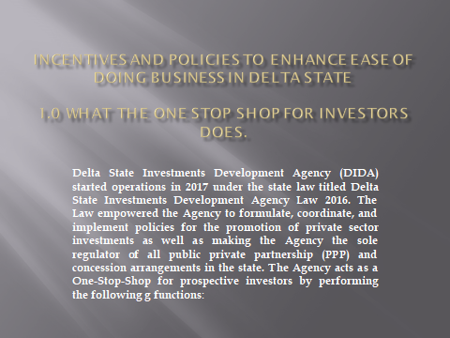

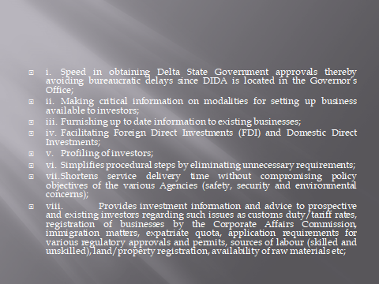

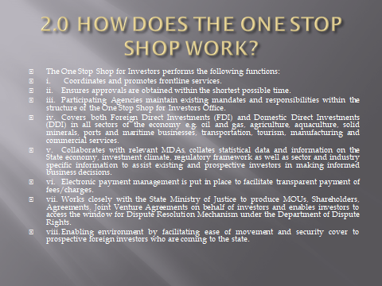

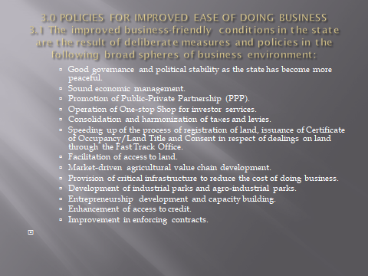

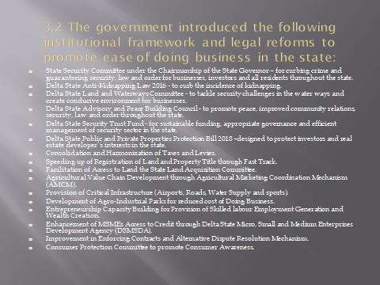

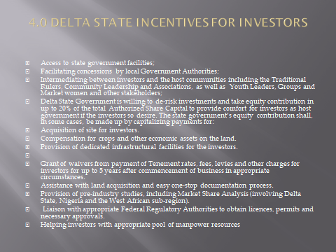

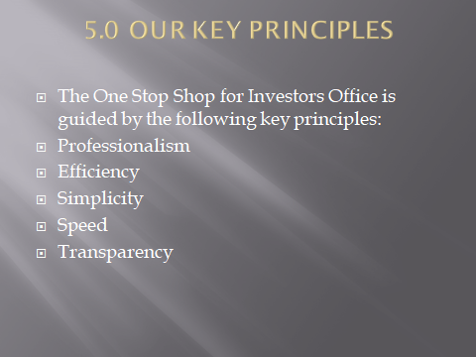

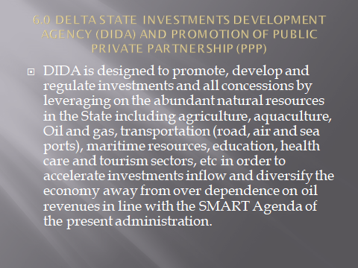

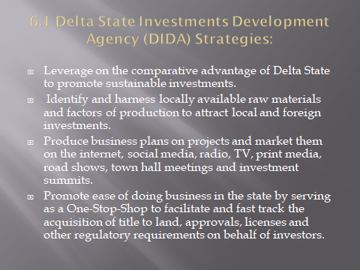

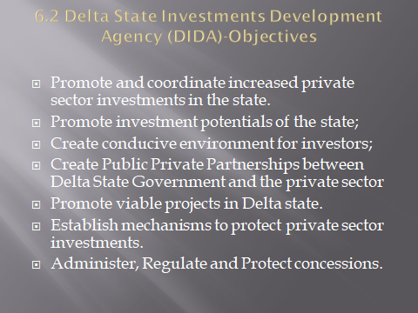



**OLOROGUN LUCKY OGHENE-OMORU**

Director General

Delta State Investments Development Agency (DIDA)/

Delta State Ease of Doing Business Reform Champion